Sulz am Neckar, December 2021

Top marks from customers:
KIPP is awarded new TÜV Service certification

HEINRICH KIPP WERK once again achieved excellent results in a representative survey conducted by TÜV Saarland. The company achieved an overall rating of "very good" in the categories of customer satisfaction and service quality.

Every two years, KIPP customers in Germany are polled by TÜV Saarland. Among other things, the survey examines whether the respondents are satisfied with the services, which criteria are particularly important and how individual process steps are rated. This year, the survey was conducted online for the first time.

"We are particularly pleased that 99.4% of the customers surveyed would order from KIPP again," says Nicolas Kipp, Managing Director of KIPP. "This validates our service strategy and provides an incentive to continue to provide the best service possible." There were hardly any deviations compared to the last survey: The five most important criteria are: Item availability (score 1.56), product quality (1.36), adherence to delivery dates (1.47) as well as rapid order processing (1.44) and delivery (1.56).

KIPP produces at its Sulz am Neckar site in Germany and the product range comprises 55,000 items.
The company can always guarantee a good delivery capability thanks to a high vertical range of manufacture, large storage capacities and an advanced logistics centre. Standard items are available from stock, urgent orders reach the customer within 24 hours.

(Characters including spaces: 1,530)

Image overview:
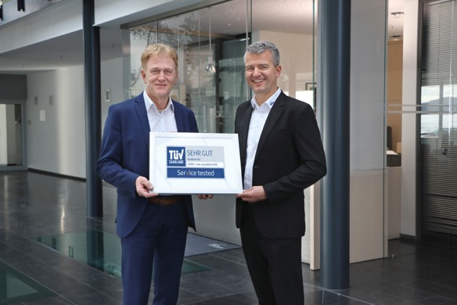
Jubilation at HEINRICH KIPP WERK: Otto Braun, Head of Sales (left) and Markus Pfeffer, Head of Sales Germany accept the new TÜV Service certification.

Image: KIPP

HEINRICH KIPP WERK GmbH & Co. KG
Stefanie Beck, Marketing
Heubergstrasse 2
72172 Sulz am Neckar, Germany

Telephone: +49 7454 793-30
Email: stefanie.beck@kipp.com

