Sulz am Neckar, May 2023

20 Years KIPP FRANCE:
A success story in French

KIPP will celebrate the 20th anniversary of its branch in France on the 10th June 2023. Opened in 2003 by the German-French owner family with initially only one employee, the subsidiary has developed into a permanent fixture on the French market over the past two decades. KIPP FRANCE SAS now has several thousand active customers who have ordered millions of products.

KIPP has written a success story in the French market over the past 20 years with innovation, quality and service. Today, the products of the family-owned company based in Sulz am Neckar, Germany are an integral part of the everyday lives of many designers in France. KIPP laid the foundation stone for this on 10th June 2003 with the establishment of a branch near Paris. Currently, six employees support numerous French industrial companies in many sectors from the new location in Vélizy-Villacoublay. Thus, products from the extensive KIPP product range find use in e.g. the aviation, automotive and foodstuff industries as well as in the pharmaceutical sector.

"Our turnover on the French market has almost tripled in the last ten years," sums up Patrick Kargol, Director of the French branch. "By 2022, we had supplied our customers in France with more than one million products, and the trend is upwards." According to KIPP, this positive development is a gratifying confirmation of the company's philosophy, which not only stands for innovative and sustainable products, but also offers the customer comprehensive service and rapid delivery. The manufacturer of clamping technology, standard elements and operating parts guarantees the durability of its products, reliable delivery and fair prices.

Today, the name KIPP stands for more than 65,000 products that are produced in a large machine park and high vertical range of manufacture at its location in Germany. The company employs a total of 480 people worldwide. With 12 branches of its own and 50 international agencies, KIPP is always close to its customers.

(Characters including spaces: 2,037)

Image overview:

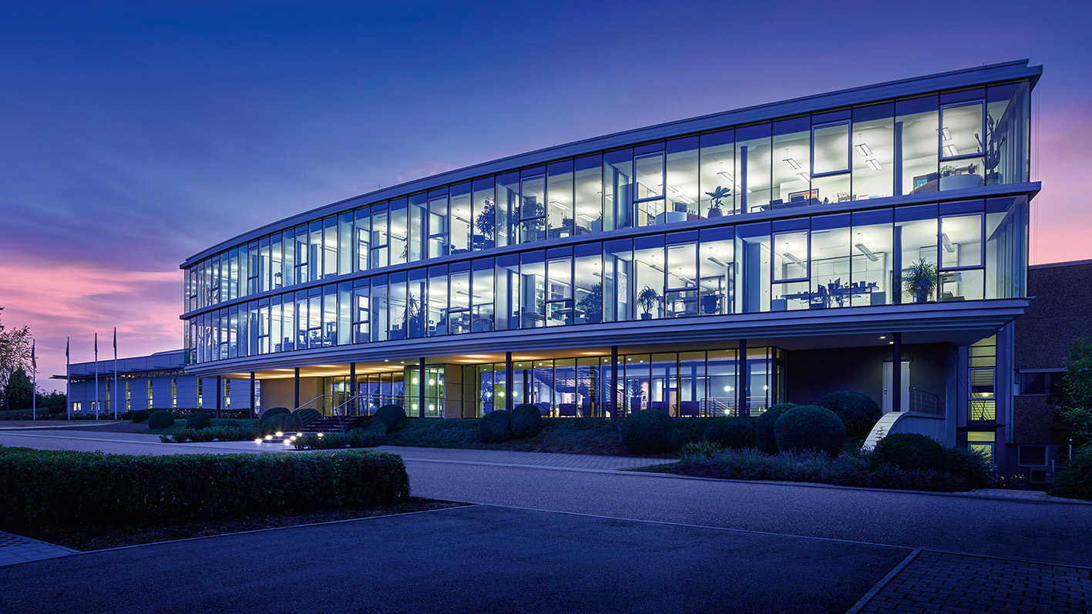
KIPP_20_Jahre_Frankreich_1.jpg
KIPP has written a success story in the French market over the past 20 years with innovation, quality and service. Today, KIPP FRANCE SAS has several thousand active customers
Image: KIPP

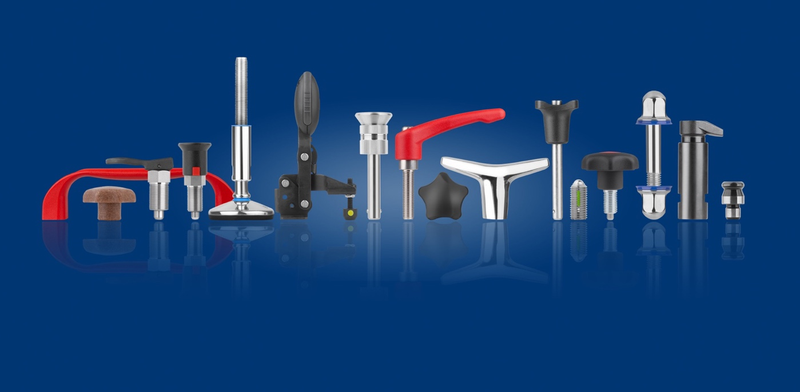
KIPP_20_Jahre_Frankreich_2.jpg
Today, HEINRICH KIPP WERK stands for more than 65,000 products.
Image: KIPP

Deeplinks:

Additional information and press photos
See www.kipp.com, Region: Germany, Category: News / Press section

Meta-Title: KIPP FRANCE SAS celebrates its 20th anniversary.

Meta-Description: KIPP writes a success story on the French market with innovation, quality and service.

Keywords: KIPP, HEINRICH KIPP WERK, KIPP FRANCE SAS, anniversary, aviation, automotive, foodstuff industry, pharmaceutical, quality, reliable delivery, fairness guarantee

Download Area:
https://www.kippwerk.de/de/en/Products/Clamping-technology.html

KIPP FRANCE SAS
Patrick Kargol - Director KIPP FRANCE
Immeuble Blériot – Vélizy Espace
13 Avenue Morane Saulnier
78140 Vélizy-Villacoublay

Telephone : +33 673631528
Email: patrick.kargol@kipp.fr

Press office:
Köhler + Partner GmbH
Brauerstrasse 42 • 21244 Buchholz i.d.N.
Telephone +49 (0) 4181 92892-0 • Fax +49 (0) 4181 92892-55
info@koehler-partner.de • www.koehler-partner.de

