Sulz am Neckar, July 2023

New aluminium handwheels from KIPP:
Ergonomic grip, safe processes

The new aluminium handwheels from HEINRICH KIPP WERK impress not only visually, but also in terms of ergonomics and operational safety. Thanks to the innovative design, these control elements are particularly user-friendly and blend practically seamlessly into the production process. There are six versions in differing sizes and two colours to choose from.

HEINRICH KIPP WERK has expanded its product range with a series of especially light aluminium handwheels that perfectly combine function and design. The control elements were primarily designed for use in machine and plant construction to make manual adjustments and settings on e.g. armatures, machine tools or transmission motors. In addition, emergency operation of individual machine parts is possible using the handwheels.

The aluminium handwheels are available as spoked or disc versions, without grips or with rotating or fold-down cylinder grips. The latter offers the user optimised haptics and very good grip due to its tapered profile and a cylindrical step. When folded down the grip sinks completely into the handwheel body. This reduces interfering contours and at the same time minimises the risk of injury. Further advantages are the low installation height by the versions without grips and with fold-down grips, the material-related low weight and the tight tolerance in radial and axial run-out of less than 0.4 mm.

For mounting the handwheels, there are frictional and positive fit variants
- with reamed hole
- with reamed hole and keyway
- with reamed hole and transverse bore or
- with reamed hole, keyway and transverse bore
available. A black hub cover improves the appearance and reduces the ingress of dirt.

All models have a durable powder coating and are available in either black or silver. The spoked handwheels come with a diameter of 125 mm and 160 mm, the disc handwheels are available from 80 mm to 125 mm.

(Characters including spaces: 1,961)

Image overview:
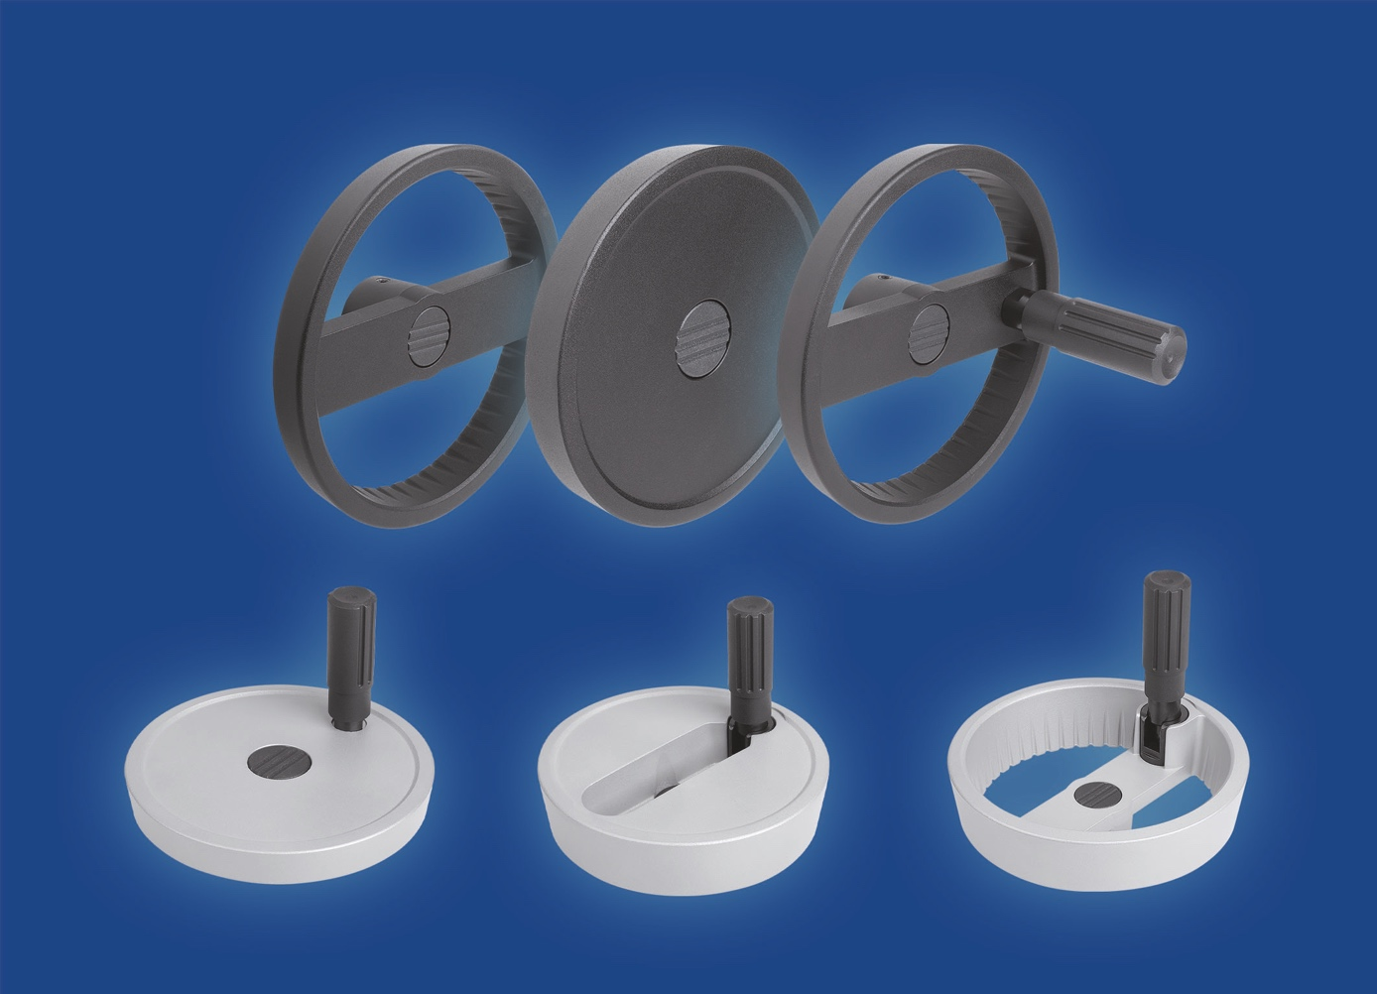
The new aluminium handwheels from KIPP are available as spoked or disc versions, without grips or with rotating or fold-down cylinder grips. All models have a durable powder coating and are available in black or silver.
Image: KIPP

Deeplinks:
https://www.kipp.com/gb/en/News/KIPP-News/Aluminium-handwheels.html

Additional information and press photos
See www.kipp.com, Region: Germany, Category: News / Press section

Meta-Title: Ergonomic aluminium handwheels from KIPP

Meta-Description: The aluminium handwheels in six different designs have optimised haptics and improve operational safety in various applications.

Keywords: KIPP, HEINRICH KIPP WERK, aluminium handwheels, handwheels,
2-spoke handwheel, disc handwheel, ergonomics, work safety, control elements, armatures, packaging industry, machine tools, transmission motors, emergency operation

Download Area:
https://www.kipp.com/gb/en/Download/Press-area.html

HEINRICH KIPP WERK GmbH & Co. KG
Andre Jerke, Marketing
Heubergstrasse 2
72172 Sulz am Neckar, Germany

Telephone: +49 7454 793-7644
Email: andre.jerke@kipp.com

Press office:
Köhler + Partner GmbH
Brauerstrasse 42 • 21244 Buchholz i.d.N.
Telephone +49 (0) 4181 92892-0 • Fax +49 (0) 4181 92892-55
info@koehler-partner.de • www.koehler-partner.de

