Sulz am Neckar, March 2023

Quick and easy positioning:
New indexing plungers with twist knob from KIPP

HEINRICH KIPP WERK has expanded its comprehensive product range of indexing plungers with six new versions with twist knobs. These practical operating parts enable rapid adjustments and positioning of movable components. They are ideally suited to all applications where a change of the indexed position through lateral forces should be prevented.

The six new indexing plungers are available with indexing pin diameters of 5 mm and 7 mm. The practical thing about these positioning elements: they enable quick positioning and locking of a component by twisting and sliding. Depending on the version, the indexing plungers also have and ON/OFF or ON/MID/OFF indicator. These markings significantly reduce the risk of incorrect operation.

The housing and the pin of the positioning elements are made from nickel-plated steel. The twist knob is made from thermoplastic. The indexing pin is tapered. Matching steel conical bushes to suit both pin diameters are available as accessories.

Users can choose between indexing plungers with a thread or a flanged version. The threaded types are secured using a locknut. The flanged model is secured with three fastening screws.

The indexing plungers with twist knob from KIPP are not only ideal for positioning on guide rails in machine constructions, but also for use in fixture constructions and in packaging plants as well as for indexing on extensions or latches in vehicle technology.

(Characters including spaces: 1,705)

Image overview:
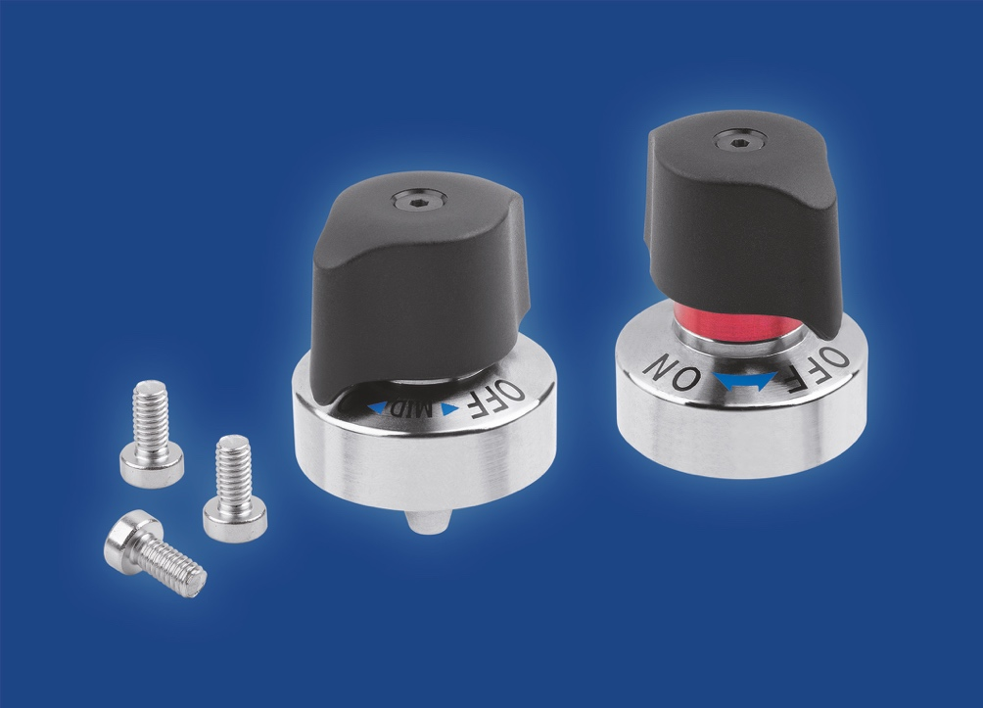
KIPP now offers indexing plungers with twist knobs. The operating parts are ideal for the rapid adjustment and positioning of movable parts

Image: KIPP

Deeplinks:
https://www.kipp.com/gb/en/News/KIPP-News/indexing-plungers-twist-knob.html

https://www.kipp.com/gb/en/Products/Operating-parts-standard-elements/Spring-plungers-indexing-plungers-ball-lock-pins/Indexing-plunger/pid.1097.1105.1226/agid.13221.20497.26588/ecm.ag/Indexing-plungers-with-twist-knob-%07and-tapered-indexing-pin.html

https://www.kipp.com/gb/en/Products/Operating-parts-standard-elements/Spring-plungers-indexing-plungers-ball-lock-pins/Indexing-plunger/Indexing-plungers-with-twist-knob-and-tapered-indexing-pin.html

Additional information and press photos
See www.kipp.com, Region: Germany, Category: News / Press section

Meta-Title: Indexing plungers with twist knob for rapid positioning

Meta-Description: The new indexing plungers with twist knob from KIPP enable rapid adjustment of movable components.

Keywords: KIPP, HEINRICH KIPP WERK, indexing plunger with twist knob, positioning element, positioning, lateral force, operating parts, machine construction, vehicle technology, packaging plants, fixture construction

Download Area:
https://www.kipp.com/gb/en/Download/Press-area.html

HEINRICH KIPP WERK GmbH & Co. KG
Andre Jerke, Marketing
Heubergstrasse 2
72172 Sulz am Neckar, Germany

Telephone: +49 7454 793-7644
Email: andre.jerke@kipp.com

Press office:
Köhler + Partner GmbH
Brauerstrasse 42 • 21244 Buchholz i.d.N.
Telephone +49 (0) 4181 92892-0 • Fax +49 (0) 4181 92892-55
info@koehler-partner.de • www.koehler-partner.de

